
Karachi Institute of Economics and Technology

Course: Artificial Intelligence Program: Software Engineering
Faculty: Dr. Husain Parvez Class ID: 117183
Examination: Mid-term Date: 17th April 2025
Total Marks: 50 Max. Time: 2 Hrs

- Over the past 7 years, a soccer club has been using an AI-based scouting system to predict which youth players are likely to succeed at the professional level. The model was used to assess player performance data each year, and based on the predictions, players were either marked as "Predicted Successful" or "Predicted Not Successful.". Now, after tracking the career progress of 100 players, the club wants to evaluate how well the system performed by comparing past predictions with the players’ current status. (Apply) (CLO-3) (PLO-3) (10 Marks)
The table below summarizes the comparison between predicted outcomes and actual career results:

 | Actual Positive | Actual Negative
Predicted Positive | 80 (TP) | 10 (FP)
Predicted Negative | 5 (FN) | 5 (TN)

a) Compute the Accuracy, Sensitivity, Specificity, Precision, NPV and F1 Score.

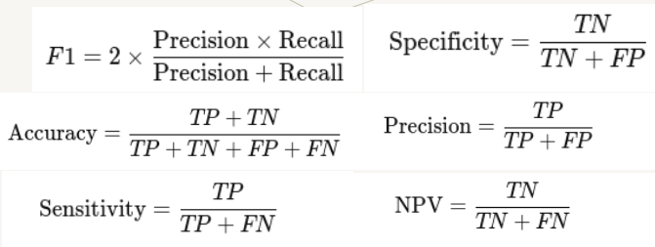

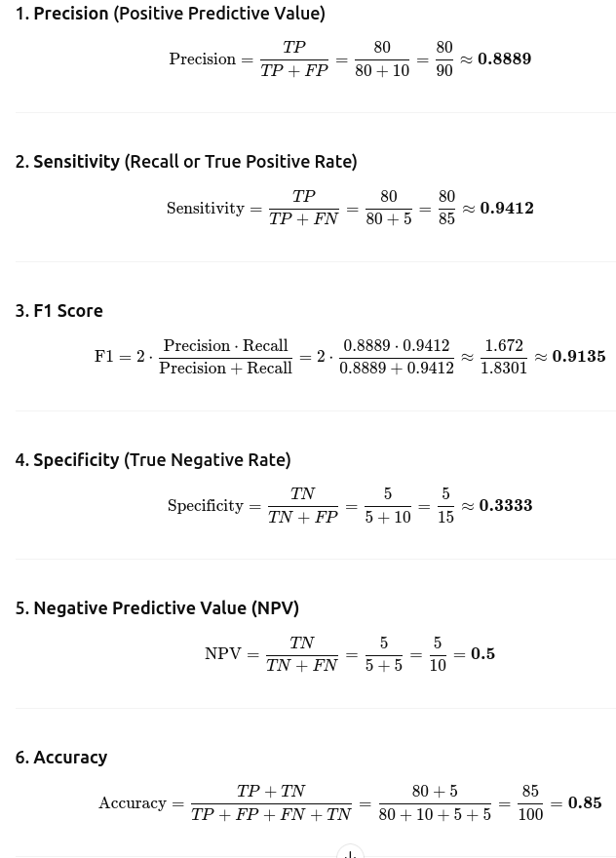

b) Match the scenarios (1 – 6) against the optimal formula to be used (a – f) in the table below.

1) Correctly identify players who didn’t succeed. | a) Specificity
2) Focuses on correctness of positive predicted stars. | b) Sensitivity or Recall
3) How many predicted negative cases are actually negative. | c) Accuracy
4) Overall correctness of the scouting system. | d) Precision
5) A balance between how many stars were found and how many were correctly predicted | e) Negative Prediction Value (NPV)
6) Correct identification of future star players | f) F1 Score

1A (Specificity)
2D (Precision)
3E ( NPV)
4C (Accuracy)
5F (F1 Score)
6B (Sensitivity or Recall)

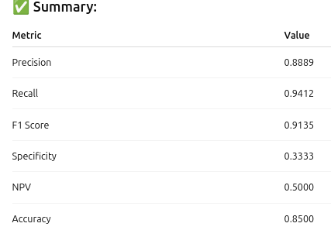

c) Evaluate which of the evaluation formulas (a – f) are useful in this scenario?

- A researcher has developed a new machine learning model to predict the presence or absence of a
disease based on patient data. The researcher wants to evaluate the performance of the model
using various metrics. Which of the following evaluation criterias (a – f) given in the previous
question, would be most suitable for each of the below given scenarios?
(Apply) (CLO-3) (PLO-3) (10 Marks)
- The researcher wants to evaluate the model's ability to detect patients who actually have the disease. (Sensitivity/Recall) (b)
- The researcher wants to evaluate the model's ability to avoid false alarms, i.e., predicting patients who don't have the disease. (Specificity) (a)
- The researcher wants to evaluate the model's overall performance, including both true positives and true negatives. (Accuracy) (c)
- The researcher wants to evaluate the model's ability to predict patients who don't have the disease. Negative Predictive Value (NPV) (e)
- The researcher wants to evaluate the model's ability to balance true positives and false positives. Precision (d)

- A postman has to deliver mail to 500 different locations in a single day. Design and implement a solution using Simulated Annealing to find the shortest possible circular route that starts and ends at the post office, visiting each location exactly once.

(Apply) (CLO-2) (PLO-2) (10 Marks)
a) Write the pseudo-code of the simulated annealing algorithm.
b) What is the role of the temperature parameter in Simulated Annealing?
c) Describe the acceptance probability formula used in Simulated Annealing.
d) Briefly describe the cost function that you will use in your algorithm?

- Describe PEAS. Mention Environment types in a particular scenario.
(Understand) (CLO-1) (PLO-1) (10 Marks)
a) What is meant by PEAS. Write one line description for each.
b) Describe different properties of Environment, and give examples.
c) What are the four types of agents?
d) Describe the five components fo the Problem solving agents.

- Greedy search
Apply the Greedy best first search algorithm from Zerind to Bucharest using the straight line
distance as shown in the table. The greedy best solution tries to expand the node that is closest to
the goal. The straight line distances are given in the table below, and the
actual road network is shown in the graph below. For each step, show the expanded tree, and
highlighting that which node was expanded. After applying the algorithm find out if the solution
found is indeed the best solution or not?
(Apply) (CLO-2) (PLO-2) (10 Marks)

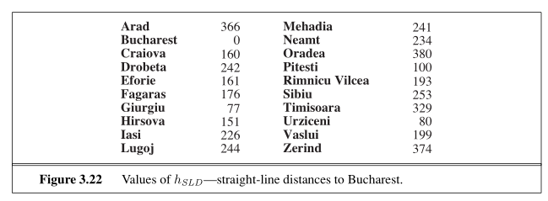

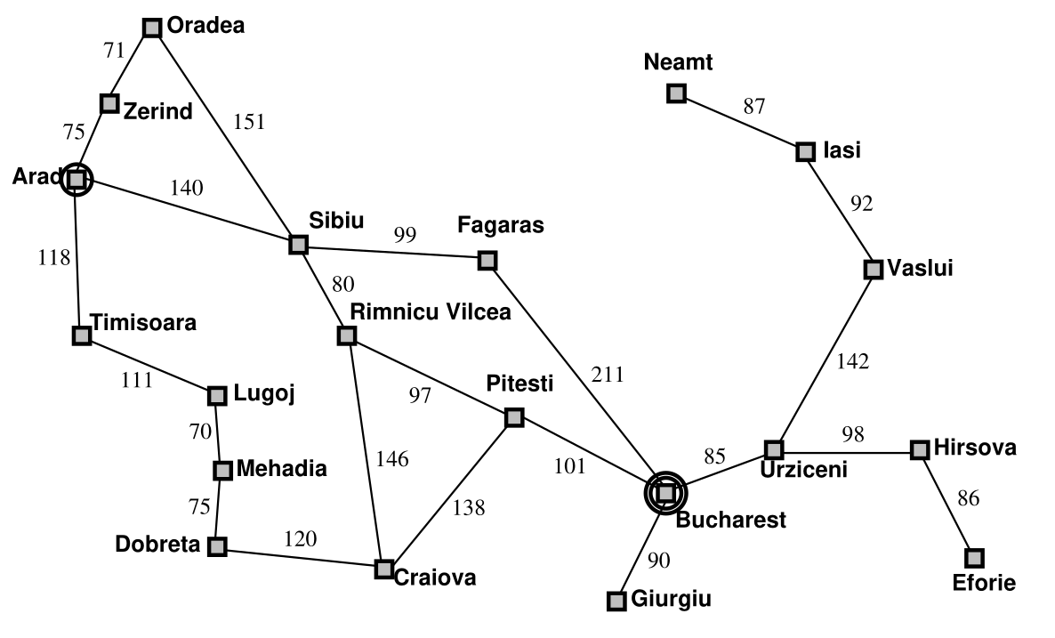

☺ Good Luck

